Image Recognition with IBM Cloud Visual Recognition

Phase 2: Innovation

* Image recognition innovation has significantly advanced in recent years, with the integration of deep learning techniques such as convolutional neural networks (CNNs). These advancements have enabled more accurate and efficient object recognition, facial recognition, and even medical image analysis.
* Additionally, innovations in computer vision and machine learning algorithms continue to drive progress in fields like autonomous vehicles, healthcare, and augmented reality, making image recognition a crucial technology in various industries.

Steps to put design into transformation :

1.Object Recognition:

Develop a system capable of accurately identifying and classifying various objects in images or videos, regardless of their orientation or background.

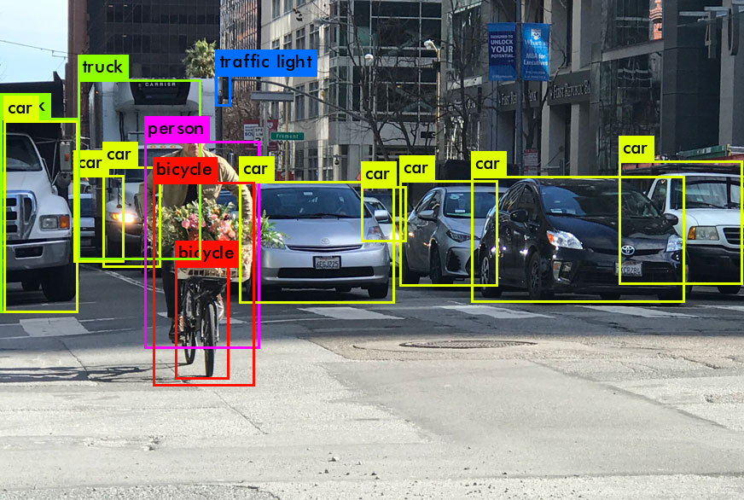

2. Facial Recognition:

Create a facial recognition system that can identify individuals from images or videos, even under different lighting conditions and facial expressions.

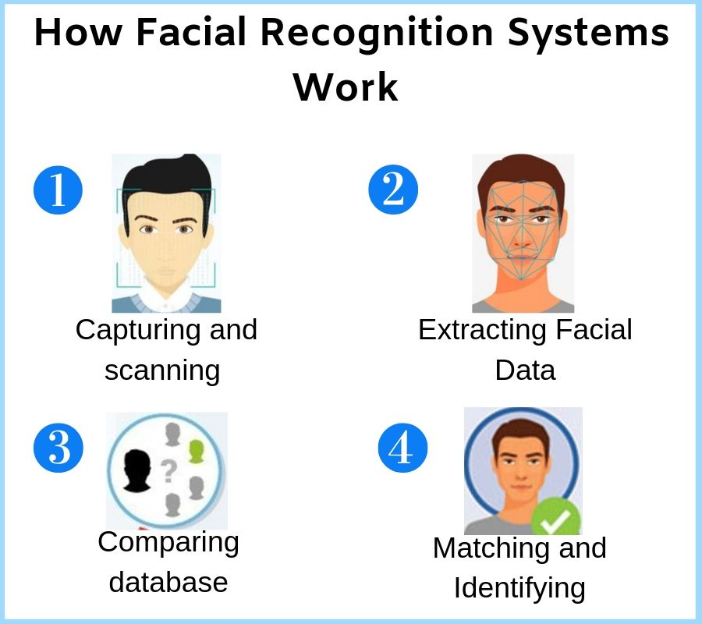

3. Scene Recognition:

Build a system that can recognize different scenes or environments from images, such as indoor, outdoor, urban, or natural settings.

4. Handwriting Recognition:

Develop an image recognition model that can accurately convert handwritten text from images into digital, editable text.



5. Medical Image Analysis:

Create algorithms to analyze medical images like X-rays, MRIs, or histopathological slides, aiming to detect diseases or abnormalities accurately.

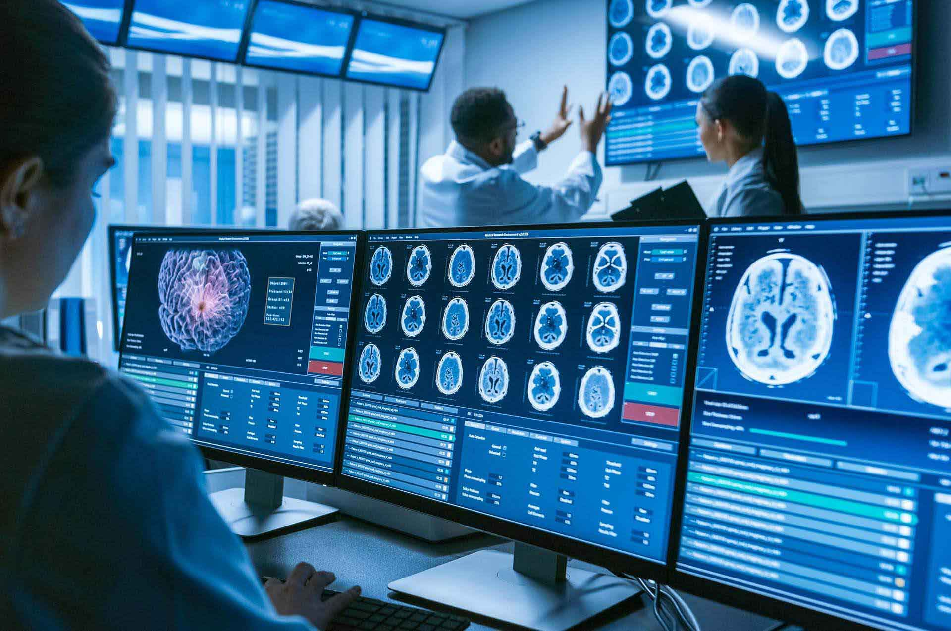

6. Emotion Recognition:

Build a system that can recognize human emotions from facial expressions in images, enabling applications in sentiment analysis and human-computer interaction.

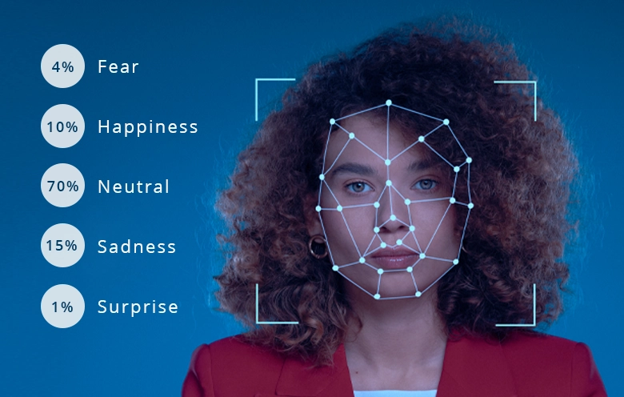

7. Logo Recognition:

Develop a system capable of identifying and categorizing logos from images, which is valuable for brand monitoring and market research.

8. Automated Captioning:

Create an image recognition model that can generate descriptive captions for images, making images more accessible to people with visual impairments.

9. Visual Search:

Implement a system that allows users to search for products or information online using images as queries, requiring accurate image recognition and retrieval techniques.

10.Monitoring and Optimization :

Monitor the performance of your image recognition system and optimize your model and application as needed.

Consider retraining your model with additional data for continuous improvement.

11. Forgery Detection:

Develop algorithms to detect digital image forgeries and manipulations, ensuring the authenticity and integrity of images in various applications.

These problem statements highlight the diverse applications and challenges within the field of image recognition.

Researchers and developers continue to work on these problems to improve the accuracy, efficiency, and applicability of image recognition technologies